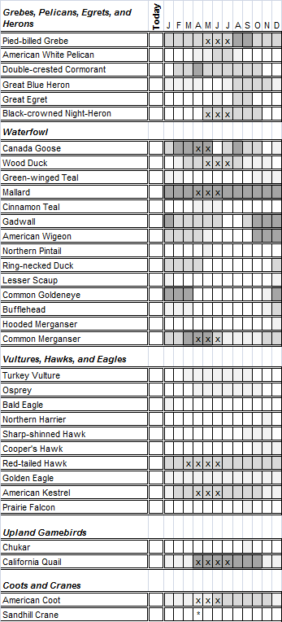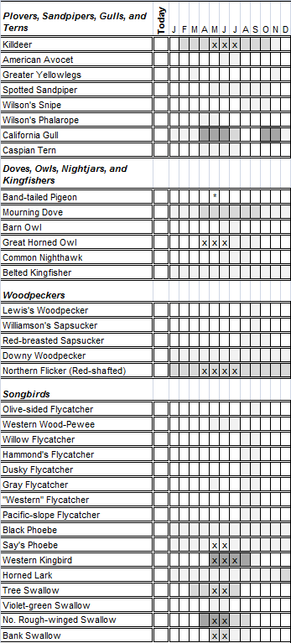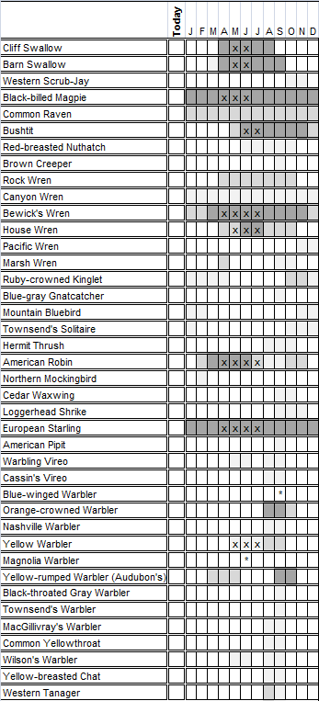

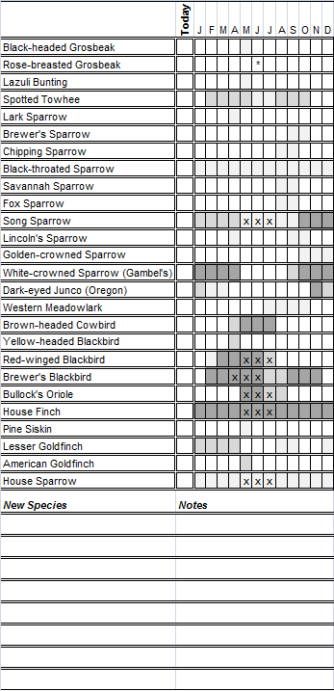

Birding at the McCarran Ranch Preserve:

The McCarran Ranch Preserve was established in 2003 by The Nature Conservancy and it features several miles of trails with frequent access to the river and oxbow wetlands. An exciting 134 bird species, including 33 breeding species and several interesting rarities, have been recorded over 9 years of birding and research at the preserve. This checklist was created using research data and reliable birding records from the preserve, and we especially thank Ken Voget, Dennis and Becca Serdehely, and Diane Wong for their contributions. Most of the past birding and research took place during the summer and fall and, undoubtedly, additional species are yet to be documented on the preserve. Birders are encouraged to submit new records to the Great Basin Bird Observatory (email to ammon@gbbo.org) and, if rarities are encountered, to submit these to the Nevada Bird Records Committee (http://www.gbbo.org/nbrc/index.htm).

Checklist Codes:

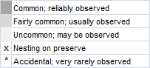

Directions to McCarran Ranch:

The McCarran Ranch Preserve is located approximately 15 minutes from Reno, NV. Take I-80 East from Reno to the Patrick exit (#28). Follow Waltham Way south across the Truckee River. Turn right at intersection and then right again onto Wild Horse Canyon Drive. Access road to trailhead will be on your right after approximately 1/4 mile.

Birds of the McCarran Ranch Preserve, Nevada

A Seasonal Checklist

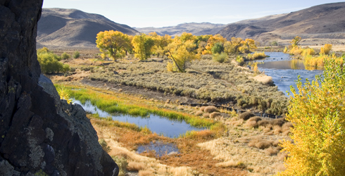

May 2012

Prepared by:
Great Basin Bird Observatory

And The Nature Conservancy

Name of Birder:_______________________________

Visit Date:____________________________________

Notes:_______________________________________

____________________________________________

____________________________________________

